About Du Yufeng of Guangyuan Bo Ai Animal Protection Center
"Protecting animals and cherishing life must start from childhood"
Based on the harm that global climate change brings to humans and biodiversity, we should pay more attention to animal protection starting with young people. Carrying out animal protection publicity and education for young people is conducive to cultivating their moral sentiments and benevolent spirit, establishing the concept of respecting and reverence for life, and is of great significance to the protection of biological diversity. Because adolescence is a critical period for the formation of good moral character in life, and a special stage that determines the quality of life's morality and character. Young people are the future of the country, the bearers of the great cause of national rejuvenation, and the successors and inheritors of Chinese civilization. In addition to etiquette education, China's ancient times also paid special attention to moral education. For example, Wang Mingyang's "Ming Human Relations" in the Ming Dynasty took moral education as the core and focused on cultivating children's moral cultivation of "filial piety, courtesy, justice, integrity and shame". Everything in the world has spirit and vitality, including humans, animals, plants, etc. Parents should let their children have a correct understanding of life, let them learn to respect every life, revere life, and not easily harm life, including themselves, others, and the animals and plants around them, so that children can know how to care for life and protect animals. What is more important is to cultivate the benevolence and friendliness of young people. When no one has the heart to cruelly harm weak animals for temporary happiness or economic gain, benevolence can be truly reflected, between classmates and parents. , The relationship between people will be harmonious. A person who loves animals will also have a strong sense of responsibility for family, friends, and society. Only then can our society and country continue to develop, be civilized, and progress.
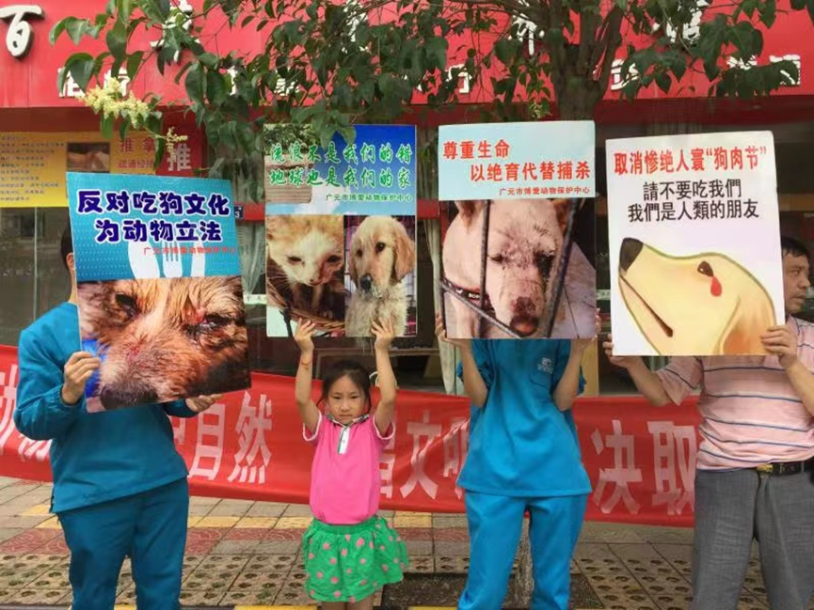
Nowadays, many teenagers abuse animals for fun and post them on the Internet. This is not only harmful to the public's physical and mental health, but also violates the spirit of the central government's advocacy of a civilized and harmonious society. Animal abuse is a manifestation of violence and is closely related to criminal activities. This kind of public violence has led to the cruelty and indifference to the eyes and ears, especially the inducement of juvenile criminal tendencies. It has become a factor that cannot be ignored in social insecurity and moral collapse. Therefore, animal protection is very important to the moral education of young people, and the importance of animal protection to environmental protection cannot be ignored. Protecting biological diversity is not only of great value to humans, but also a valuable asset to all living things on earth.
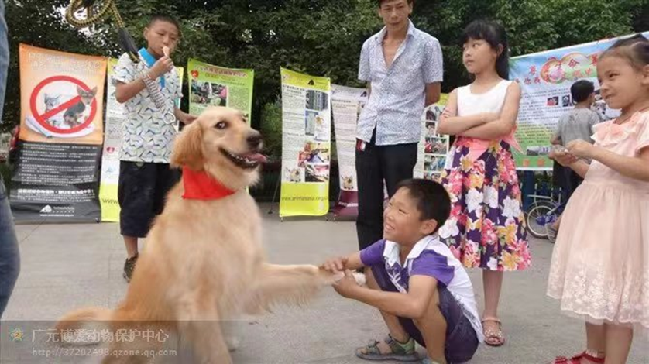
Our country's traditional culture contains many ideas related to animal protection, which is a valuable ideological and mass basis for us to carry out animal protection education and practice. In our country’s traditional culture, Buddhist ethics, Taoism and Confucianism can be regarded as the three major gospels that guide people to be benevolent and do good deeds. Together, they constitute the theoretical context of animal protection ethics in ancient Chinese society. The thoughts of animal protection in Chinese Buddhist ethics are often based on the "equality of all living beings", "great compassion", and the belief that "all living beings have Buddha nature" and that all beings, including living animals and plants, and even inanimate grass, trees, mountains and rivers, etc., have a broad charitable and compassionate heart towards all beings. Compassion for all sentient beings with universal, equal and undifferentiated compassion, not abandoning all sentient beings, and saving all sentient beings from the sea of suffering. We can understand this as ritual morality. This kind of thinking also profoundly affects people's daily behavior, making people have great sympathy and concern for the suffering of animals, and assume the responsibility of caring and loving all living beings. This plays an indispensable role in the practice of animal and plant protection. Estimated positive impact.
There are many thoughts in Taoist theory involving the ecological environment, including many theories related to animal protection, mainly including "kindness towards things", "Tao nature cherishes life", "retribution for good and evil", etc. The so-called "kindness to things" refers to giving kindness to animals and plants, so as to achieve the purpose of protecting animals and plants. "Tao Xing Guisheng" refers to the Taoist idea of equality of all living beings and respect for life. Taoism expands the object and scope of moral care from human and social fields to other life and the entire natural world, and projects the moral care between people to animals, thus forming the object of protection for all life and existence.
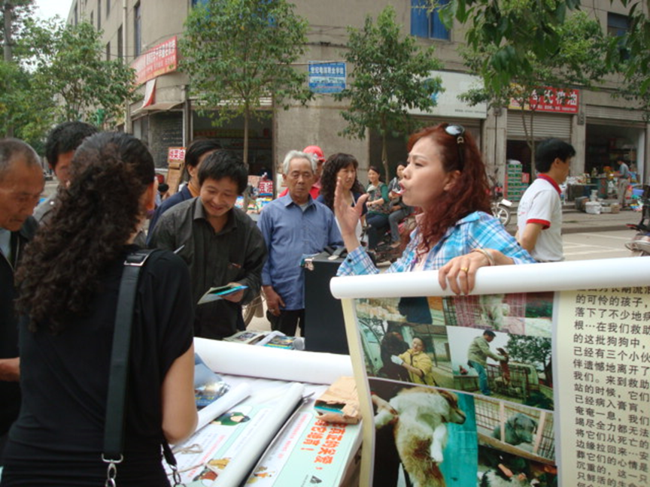
Therefore, protecting animals and cherishing life must start from childhood. Protecting biodiversity and protecting animals and cherishing life education are to improve young people's environmental awareness, care for animals and plants, and to maintain public facilities and promote the coordinated development of human beings, human beings and society, and human beings and nature. Animals are friends of humans. If humans give them a little love, our only home, the earth, will be better. Caring for animals means caring for humans themselves.
Let children know that animals and we are part of the same family on the same planet. They and our lives should be equal. The existence of animals makes the world more dynamic and extraordinary. Without animals, how lonely we would be!
There is a long way to go to protect animals! Caring for animals starts with me, which means caring for our common home!
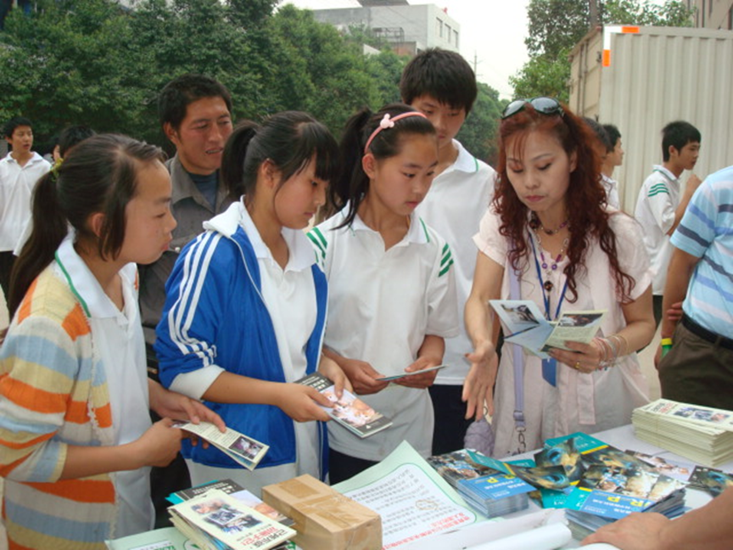
Liang Qichao's "Young China" mentioned:
“Today’s responsibility does not lie with others, but with my young man.
The wisdom of young people will make the country wise, the richness of young people will make the country rich; the strong young people will make the country strong; the independent young people will make the country independent; the free young people will make the country free; the progress of young people will make the country progress;
If a young man is better than Europe, the country will be better than Europe; if a young man is more powerful than the earth, the country will be as powerful as the earth."
For the prosperity of the motherland, for the healthy growth of the young children of the motherland! Caring for animals and cultivating kindness must start from childhood!
